Choose the Right Hardware

Proposal Template

# Scenario 1: Manufacturing

Client Requirements and Potential Hardware Solution

Look through the scenario and find any relevant client requirements. Then, suggest a potential hardware type and explain how this hardware would satisfy each of the requirements.

|  |  |  |
| --- | --- | --- |
| **Which hardware might be most appropriate for this scenario?**  **(CPU / IGPU / VPU / FPGA)** | | |
| *FPGA* | | |

|  |  |  |
| --- | --- | --- |
| **Requirement Observed**  **(Include at least two.)** | **How does the chosen hardware meet this requirement?** | |
| In manufacturing the client need a high quality system which should run for long time i.e.,atleast 5-10 years.and client has sufficient investment | FPGA’s won’t be outdate even if they use for long years | |
| Client can optimize this type in future | *Because FPGA’s are reprogrammable* | |

## Queue Monitoring Requirements

|  |  |  |
| --- | --- | --- |
| **Maximum number of people in the queue** | *5* | |
| **Model precision chosen (FP32, FP16, or Int8)** | *I used FP32 for cpu and for remaining(IGPU,VPU,FPGA) i used FP16* | |

## Test Results

After you've tested your application on all four hardware types (CPU, IGPU, VPU, and FPGA), copy the matplotlib output showing the comparison into the spaces below. You should have three graphs (for model load time, inference time, and FPS).

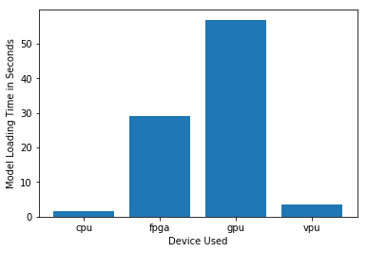

***Model Load Time***

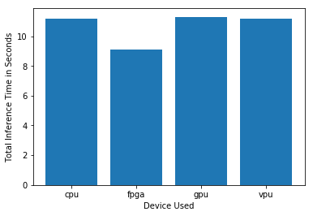

***Inference Time***

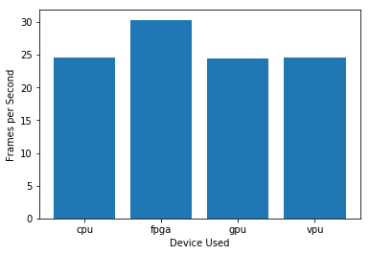

***FPS***

## Final Hardware Recommendation

Now synthesize your points from above and provide a brief write-up describing why the chosen hardware is the best choice for this scenario. Be sure to discuss the client's requirements, the test results, and how these relate to one another (e.g., perhaps one of the devices performed better than the rest, but does not meet one of the client's requirements).

|  |  |  |
| --- | --- | --- |
| **Write-up: Final Hardware Recommendation** | | |
| *Client has sufficient revenue to upgrade there hardwares.so i recommended them to go for FPGA.this will be the best result in output.i future they can reprogramme this device for there requirements without upgrading in hardware.* | | |

# 

# Scenario 2: Retail

Client Requirements and Potential Hardware Solution

Look through the scenario and find any relevant client requirements. Then, suggest a potential hardware type and explain how this hardware would satisfy each of the requirements.

|  |  |  |
| --- | --- | --- |
| **Which hardware might be most appropriate for this scenario?**  **(CPU / IGPU / VPU / FPGA)** | | |
| *IGPU* | | |

|  |  |  |
| --- | --- | --- |
| **Requirement Observed**  **(Include at least two.)** | **How does the chosen hardware meet this requirement?** | |
| *Client doesn’t has enough budget to upgrade to new hardware* | *But client has i7 skylake which has integrated graphics so i recommended to use that only* | |
| *By this client can save as much as possible* | *Because this type of processors consume low power so that he could save money in electricity bill as well* | |

## Queue Monitoring Requirements

|  |  |  |
| --- | --- | --- |
| **Maximum number of people in the queue** | *2-5* | |
| **Model precision chosen (FP32, FP16, or Int8)** | *FP32* | |

## Test Results

After you've tested your application on all four hardware types (CPU, IGPU, VPU, and FPGA), copy the matplotlib output showing the comparison into the spaces below. You should have three graphs (for model load time, inference time, and FPS).

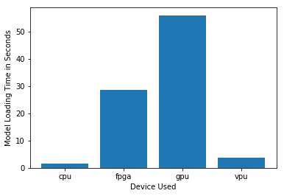

***Model Load Time***

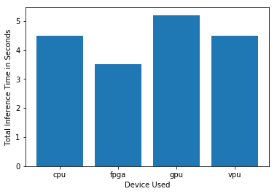

***Inference Time***

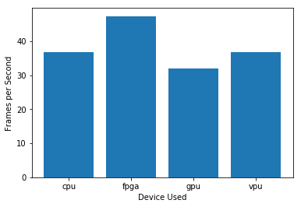

***FPS***

## Final Hardware Recommendation

Now synthesize your points from above and provide a brief write-up describing why the chosen hardware is the best choice for this scenario. Be sure to discuss the client's requirements, the test results, and how these relate to one another (e.g., perhaps one of the devices performed better than the rest, but does not meet one of the client's requirements).

|  |  |  |
| --- | --- | --- |
| **Write-up: Final Hardware Recommendation** | | |
| *Mr. Lin does not have much money to invest in additional hardware, and also would like to save as much as possible on his electric bill.so using IGPU can save as much as possible by different perspectives* | | |

# 

# Scenario 3: Transportation

Client Requirements and Potential Hardware Solution

Look through the scenario and find any relevant client requirements. Then, suggest a potential hardware type and explain how this hardware would satisfy each of the requirements.

|  |  |  |
| --- | --- | --- |
| **Which hardware might be most appropriate for this scenario?**  **(CPU / IGPU / VPU / FPGA)** | | |
| *VPU* | | |

|  |  |  |
| --- | --- | --- |
| **Requirement Observed**  **(Include at least two.)** | **How does the chosen hardware meet this requirement?** | |
| *Example requirement:*  The client requires a tiny device to be connected to their CPU—and their budget is only about $300 for each device. | *Example explanation:*  VPU or NCS2 is only about 27.40 mm in size and would fit in the price range. | |
| Buying 2 to 3 NCS2 its a budget because a single NCS2 cost 70-100$ | Using these sticks in parallel gets better performance as a results with low electric power consumption | |

## Queue Monitoring Requirements

|  |  |  |
| --- | --- | --- |
| **Maximum number of people in the queue** | *7-15* | |
| **Model precision chosen (FP32, FP16, or Int8)** | *FP32* | |

## Test Results

After you've tested your application on all four hardware types (CPU, IGPU, VPU, and FPGA), copy the matplotlib output showing the comparison into the spaces below. You should have three graphs (for model load time, inference time, and FPS).

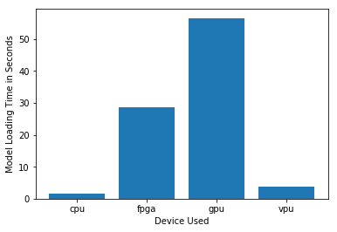

***Model Load Time***

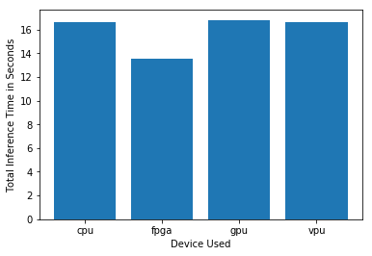

***Inference Time***

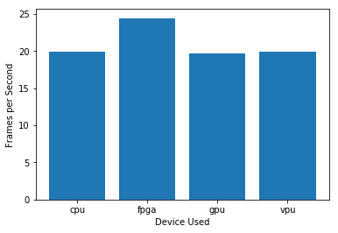

***FPS***

## Final Hardware Recommendation

Now synthesize your points from above and provide a brief write-up describing why the chosen hardware is the best choice for this scenario. Be sure to discuss the client's requirements, the test results, and how these relate to one another (e.g., perhaps one of the devices performed better than the rest, but does not meet one of the client's requirements).

|  |  |  |
| --- | --- | --- |
| **Write-up: Final Hardware Recommendation** | | |
| *Ms. Leah's budget allows for a maximum of $300 per machine, and she would like to save as much as possible both on hardware and future power requirements.so using NCS2 in parallel can give him best performance with low electric power consumption* | | |

# 